Archana Sharma

RA1911042030007

MINI PROJECT

LOCATION TRACKER

# LOCATION TRACKER

**A MINI PROJECT-1 REPORT**

***Submitted by***

## ARCHANA SHARMA [Reg No:RA1911042030007]

*Under the guidance of*

## DR. P. SIVAKUMAR

(Associate Professor, Department of Computer Science Engineering)

***in partial fulfillment for the award of the degree of***

**BACHELOR OF TECHNOLOGY**

in

## COMPUTER SCIENCE ENGINEERING

of

**FACULTY OF ENGINEERING AND TECHNOLOGY**



SRM INSTITUTE OF SCIENCE AND TECHNOLOGY, NCR CAMPUS

**May 2021**

SRM INSTITUTE OF SCIENCE AND TECHNOLOGY

(Under Section 3 of UGC Act, 1956)

## BONAFIDE CERTIFICATE

Certified that this project report titled “**LOCATION TRACKER**” is the bonafide work of “**ARCHANA SHARMA [RA1911042030007]”**, who

carried out the project work under my supervision. Certified further, that to the best of my knowledge the work reported herein does not form any other project report or dissertation on the basis of which a degree or award was conferred on an earlier occasion on this or any other candidate.

**SIGNATURE**

Dr. P. Sivakumar

**GUIDE**

Associate Professor

Dept. of Computer Science Engineering

Signature of the Internal Examiner

**SIGNATURE**

Dr. R.P. Mahapatra

**HEAD OF THE DEPARTMENT**

Dept. of Computer Science Engineering

Signature of the External Examine

# 

# ABSTRACT

Cell phones fill in as a specialized device used to send messages, put and get calls, surf the web. In this paper, we present an application that assists us with following and pin-point the current area of a Cell Phone. This framework is planned by consolidating the idea of Google Map SDK that gives different organization suppliers: GPS and Location Network Provider. The system makes it conceivable to follow the area for a determined timeframe.

The venture includes Android Application Development of a GPS based Location Tracker in which with the assistance of any cell phone (application introduced); some other GPS empowered handset (application introduced) could be found. However, target client might be found anyplace on the planet, he should have network availability and be GPS empowered.

# ACKNOWLEDGEMENTS

We would like to express my deepest gratitude to my guide, **DR. P. SIVAKUMAR** for his valuable guidance, consistent encouragement, personal caring, timely help and providing me with an excellent atmosphere for doing research. All through the work, in spite of his busy schedule, he has extended cheerful and cordial support to me for completing this research work.

We sincerely thank staff and students of the Computer Science and Engineering Department, SRM Institute of Science and Technology, for their help during my research. Finally, we would like to thank my parents, our family members and our friends for their unconditional love, constant support and encouragement.

Thank you all!

**ARCHANA SHARMA [RA1911042030007]**

# TABLE OF CONTENTS

ABSTRACT iii

ACKNOWLEDGEMENTS iv

INTRODUCTION 7

Objective

What we will build

LITURATURE SURVEY ……………………………………………………………………….10

PROPOSED SOLUTIONS 13

SYSTEM ANALYSIS 14

* Three Source of Location Data
* Last Known Location
* Location Setting
* Location Update
* Location Request

SYSTEM DESIGN 16

* 1. Architectural diagram 16
  2. Use case Diagram 17

DESIGNING AND IMPLEMENTATION 19

* 1. Tools and Innovations Utilized The primary innovations utilized 19
  2. Google Play Service Implementation 19
  3. Results 20

CONCLUSION 22

FUTURE ENHANCEMENT 23

APPENDIX………………………………………………………….……………………………24

* 1. Java 24
  2. Things we'll implement in building this tracker…………………………………….25

REFERENCES 26

**CHAPTER 1**

## INTRODUCTION

All cell phones are continually in contact with the closest cell phone pinnacles and sponsors to keep a decent gathering of the signs. The incorporation of the GPS chips into the cells has made this conceivable to follow a mobile phone all the more precisely. Cell phone following tracks the current situation of a cell phone, in any event, when it is moving.

To find the telephone, it should produce basically the wandering sign to contact the following close by receiving wire tower, however the cycle doesn't need a functioning call.

The more appropriately applied term finding alludes to the reason rather than a situating interaction. Such help is presented as a choice of the class of area-based administrations which utilizes GPS.

The Latitude and longitude of the cell phone's area is looked by the Google Play service. It sends the information to the Internet through Network attachment with a specific IP address. Subsequently the information arrives at the terminal with the specific IP address.

**Objective: In this application we will demonstrate the use of the following features:**

1. FusedLocationProviderClient - The standard Android API used for reading GPS and cell phone tower location data.

2. Permissions - Allowing an app to track the location of the phone

3. Location Request-a class that specifies the options for how accurate and frequent location tracking should be. The settings in this object are a balance between battery power and app performance.

4. Google Play Services- information about this important dependency that Google includes in many different applications, including GPS and Maps.

5. OnSuccessListener and Location Callback - Methods triggered whenever the phone updates its GPS location.

6. Starting and Stopping location tracking.

7. GeoCode-A Google service to automatically translate a GPS location to a street address.

**What we will build**

A single activity app that allows the user to:

1. Turn location tracking on or off.
2. Specify the accuracy of the location tracking.
3. See the latitude, longitude, altitude and current traveling speed of the phone.
4. See the street address closest to the location coordinates.

# CHAPTER 2

**LITERATURE SURVEY**

|  |  |  |
| --- | --- | --- |
| **LITERATURE SURVEY** | **NAMES** | **FINDINGS** |
| **SURVEY 1** | **International Research Journal of Engineering & Technology Author name: Prof. Shrinivas Sir Deshpande** | **Due to rapid increase in population, there is need for efficient public transportation system. There is increased burden on public transportation like bus just because of population. Therefore remote user needs a smart system which provides real time information of bus. So we proposed a new system which solves the drawback of current public transportation system. So our system handles all the data like current location of bus, management of buses and its schedule. The real time tracking of bus can be done by our proposed system and this information is then given to remote user who wants to know the real time bus information. Some technologies like GPS (Global Positioning System), Google maps and GPRS (General Packet Radio Service) are used for development purpose. Our system provides web based application, which gives real time location of bus on Google Maps to remote user** |
| **SURVEY 2** | **International journal of advanced research in computer engineering & technology Author name: Prof. M.K Night** | **GPS and GSM based device location and tracking system will provide effective, real time device location, mapping and reporting this information back to monitoring device and improving the level of service provided. A GPS based device tracking system will inform where your device is and where it has been, how long it has been.The system uses geographic position and time information from the Global Positioning Satellites. Currently, mostly the existent tracking systems use techniques of virtual fence known as Geophone which compares the entity position with a predetermined zone or a point of interest, checking if the entity is inside or outside an area. Those techniques do not allow full coverage of the course, making difficult to determine if a truck or another delivery device is travelling in a planned path. Therefore, we need to use an alternative technique that allows continuous monitoring of travels, obtaining information of probable deviations or even emergency situations.** |
| **SURVEY 3** | **International Journal of Science and Research (IJSR) Author name: Miss. Poonam Sather** | **The paper describe a practical model for routing and tracking of mobile devices in a large area outdoor environment based on the Global positioning system (GPS) and Global system for mobile communication (GSM). The supporting device GPS continuously move with the car and will calculate the co-ordinates of each position and when required by the owner it can be communicated with the help of GSM modem which is installed in both Transmitter and receiver section. GSM modem is controlled by a 32 bit ARM7 LPC2148.The device will collect position to supervised center by the SMS (Short Message Service) or GPRS (General Package radio service) and which can be located in the Google Earth and so the current position of the car can be known** |
| **SURVEY 4** | **International journal of information system and engineering Author name: Mr. Joshua Samuel** | **Location based services has enable people to locate and track the location of other people, objects, machine, devices and resources, from the comfort of their home as long as they have the required gadget such as smart phone, PDA’s, and others (Abuse, et al, 2004). Requesting location sensitive information is usually initiated by a user called the client or network provider. Most application today use Global Positioning System (GPS) provide location information; for example social network site like Facebook allow users to share their location with friends and family, another common example are application that allow users retrieve weather forecast data based on their current location. With the numerous benefits emanating from the use of location-based service, there is however issues that bothers on the privacy of user; hence there is need for proper government regulations. The purpose of this project to develop a tracking / monitoring Android application (mobile) using object GPS devices to ascertain its current location, and previous location at specified intervals, this system unlike previous tracking system will give user the ability to create bookmark of current location and ability to route back to that location from anywhere using Google Maps API’s in case they can’t remember the prices location. Chandra, Jain and Qadeer used a simple web server approach along with SMS to solve the problem. It was implemented for JAVA enabled mobile devices equipped with GPS receptor. A client can either send his location to other clients directly by SMS or share it by sending it to the web server’s database via internet. Clients can view the locations on the Google maps. The aim of this application is to enables the user to share his location with their friends or even who uses the same solution.** |

# CHAPTER 3

## PROPOSED SOLUTIONS

The App "Location Tracker" is a GPS administration-based application which would help us in finding the specific geo-position of individuals (any single element of a huge set) depending upon their present area/whereabouts. Geo-position would be shown on the guide view on our android set and show working can simple to the current utilization of Google Maps/Nokia Maps/iOS Map Service. Some Key focuses about the App:

1. For limiting client access, client confirmation would be upheld.
2. Periodic refreshing has to be present so that each time the geo–location changes or after a fixed interval of time the values in database should be updated.
3. changes or after a proper time period the qualities in information base ought to be refreshed.
4. **The application would have extra help as far as**

* Street View and Satellite View
* Pin Points on the Map
* Getting Address from the Map
* Locating Multiple clients (support for a long time Points)
* Can store previous visited location
* Zooming In/Zooming Out

# 

# CHAPTER 4

## SYSTEM ANALYSIS

**Three Sources of Location Data**

Cell phones can be located using three types of signals: GPS satellite location, cell tower locations and known WIFI locations. The GPS signal is the most precise but also uses the most battery power. If multiple applications on a phone are requesting the location data of the phone, Android can provide each of them the data after a single request instead of having each application repeat the same process. All of this location requesting can be done through a single class called the FusedLocation Provider that "fuses" these features together, making your app as accurate and as energy efficient as possible. The FusedLocaitonProvider has settings for you to request the most accurate data available, or the best accuracy possible with no additional power consumption.

**Last Known Location**

Using the fused location provider API, your app can request the last known location of the user's device. Getting the last known location is usually a good starting point for apps that require location information.

**Location Settings**

Deciding which location sources to use can be challenging, but the fused location provider API removes the guesswork by automatically changing the appropriate system settings. All your app must do is specify the desired level of service.

**Location Updates**

In addition to the last known location, the fused location provider API can deliver location updates to a callback in your app at specific intervals. You can specify the desired interval as a parameter of the quality of service. By using location updates, your app can provide additional information such as direction and velocity.

**Location Request**

Related to fusedlocationProvider is a data object called Location Request that contains quality of service parameters. These parameters will be used when initializing a request to the Android class FusedLocationProvider

For example, if your application wants high accuracy location it should create a location request with setPriorityiset to PRIORITY HGH ACCURACY and setinterval(long) to 5 seconds. This would be appropriate for mapping applications that are showing your location in real time.

# CHAPTER 5

## SYSTEM DESIGN

System design helps in better and quick understanding of the system by using different types of figures and diagrams. Following of the proposed systems are: -

# Architectural diagram

Architectural diagrams is concerned with understanding how a system should be organized and designing the overall structure of that system. Below diagram helps in understanding the basic architectural structure of implementing the overall system working.

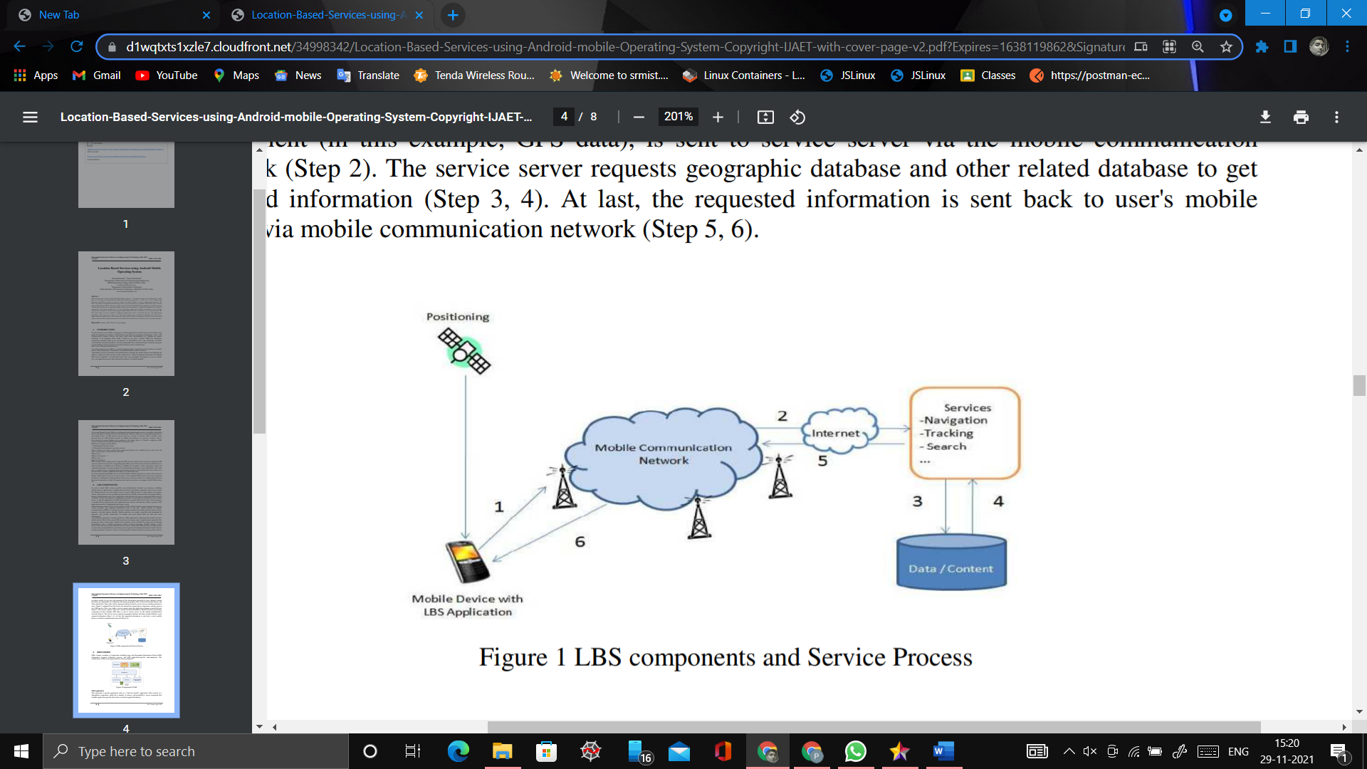

**Figure 5.1:** Architectural design

# Use case Diagram

This diagram is a behavior diagrammatical representation of different roles in a system. Below diagram helps in understanding the different role type.

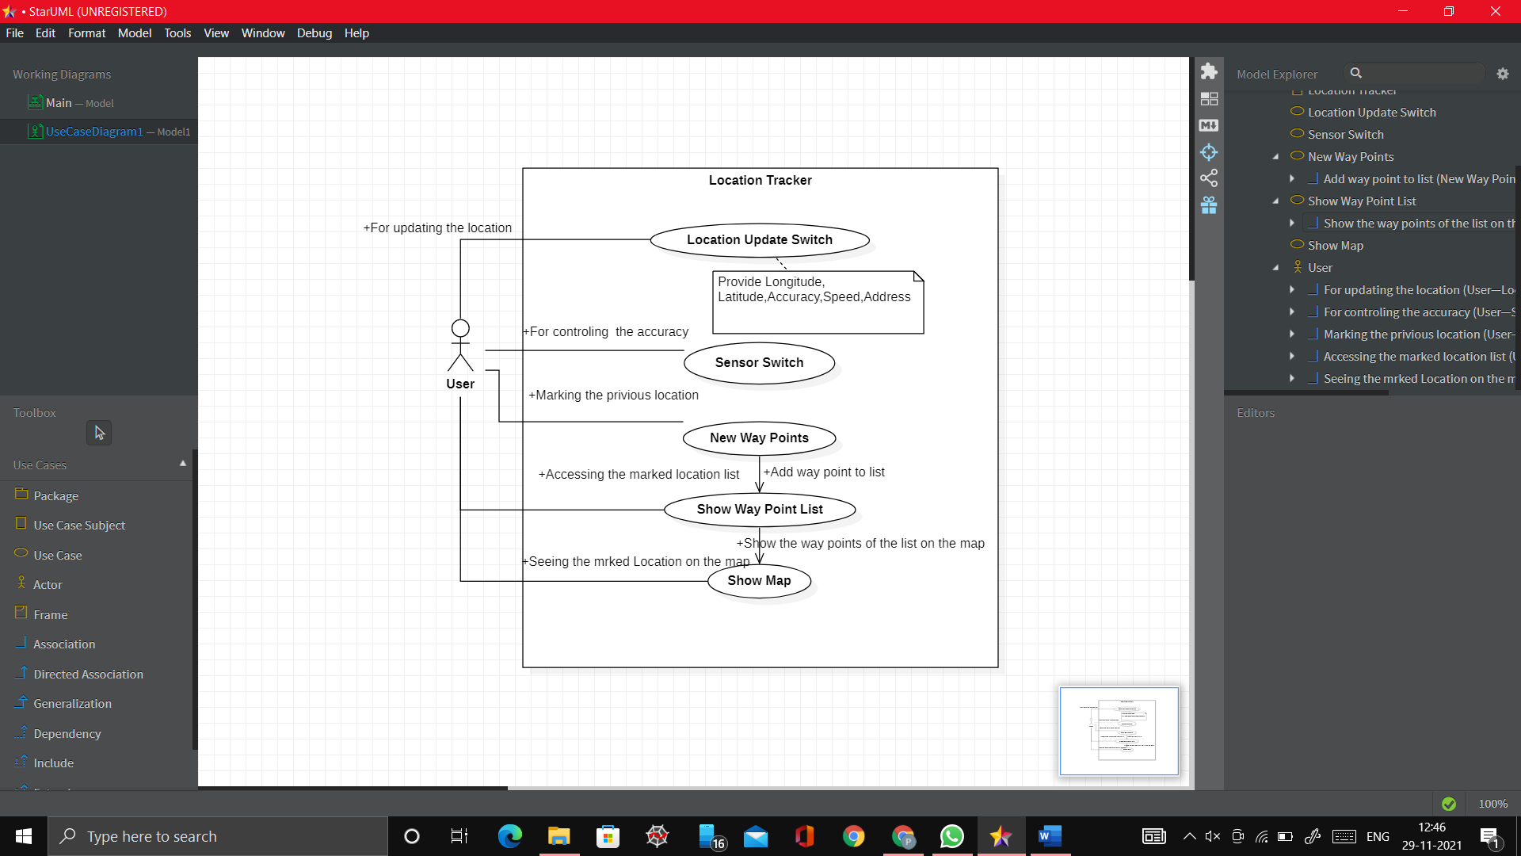

**Figure 5.2:** Use case diagram

# 

# Activity Diagram

# 

# Activity describes the dynamic aspects of the system. Activity diagram is basically a flowchart to represent the flow from one activity to another activity. The activity can be described as an operation of the system. The control flow is drawn from one operation to another

# 

**Figure 5.3:** Activity diagram

# CHAPTER 6

**DESIGNING AND IMPLEMENTATION**

1. **Tools and Innovations Utilized The primary innovations utilized are: –**

Android

Android Studio

Java

Google Map API

# B. Google Play Services Implementation

# To access the fused location provider, your app's development project must include Google Play services as a dependency in the Gradle file. Google Play services includes most of the features in an app that you would expect to utilize in many commercial products including:

# Google Sign-in: Hate having to create a new account for every new service you're interested in? If the service supports Google Sign-in, then you can quickly sign-up using your Google Account.

# Fused Location Provider: Rather than having a bunch of different apps running in the background at different times to poll the location, Google Play Services can provide the location data in a relatively battery-efficient way.

# Maps: Google Maps is by far the most popular maps and navigation apps for users. With the Maps SDK, developers can use Google Maps data in their own apps.

# Google Play Games: A lot of games, especially those from indie game developers, rely on Google Play Games Services. Developers can utilize Google Play Games when creating real-time or turn-based multiplayer games.

# C. Results

The important motive of this app is to provide current location of the mobile phone along with its latitude, longitude, altitude, speed and address with accuracy using cell tower + Wi-Fi and GPS sensor. And it will also provide your location by pin pointing on the google map and to store previous visited places.

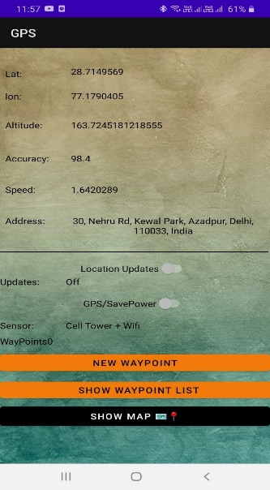 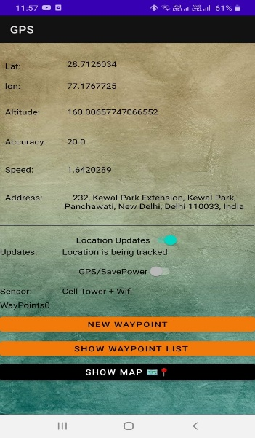 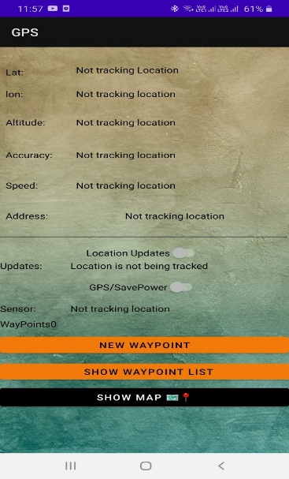

When location update is off

When location update is on

When location update switch is off

1. **Tracking current location before and after location update (2) Not tracking the location by switching off the location update switch.**

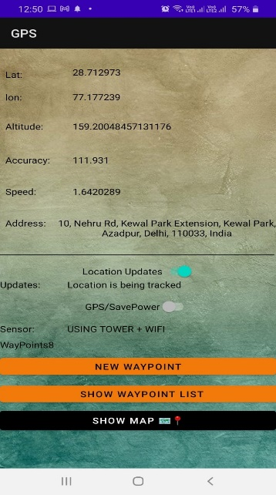  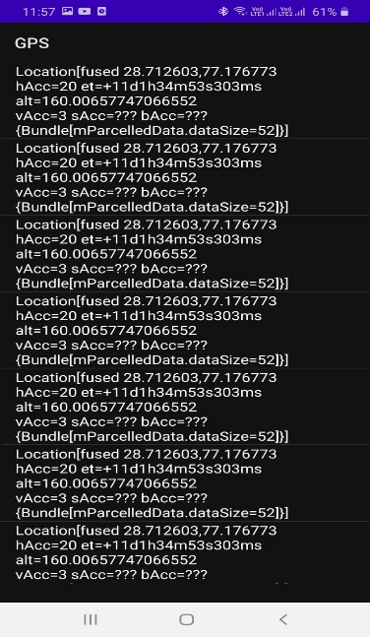

Clicking on show waypoint list button

List of all waypoints

Showing 8 waypoints after updating

**(3) Adding 8 new way points (4) Showing list of waypoints by clicking on “SHOW WAYPOINT LIST” button**

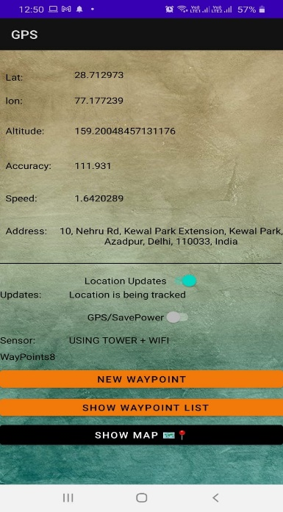

**OUTPUT OF MAP**

Clicking on show map button

**(5) Opening location on map by clicking on “SHOW MAP” button**

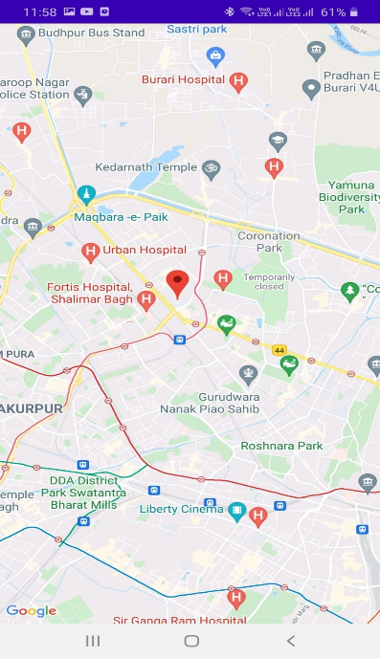 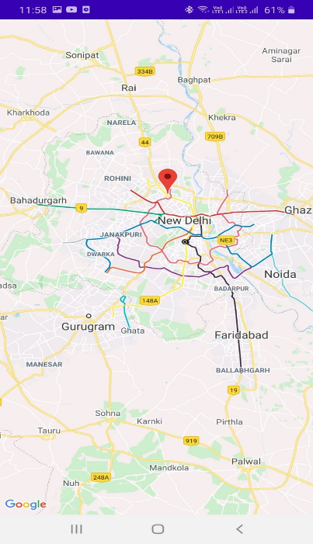 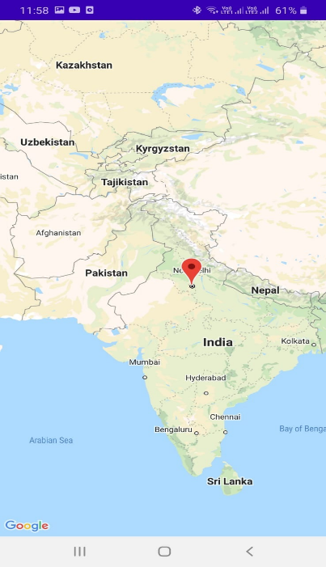

Zoom-in view of location

Zoom-out view of location

**(6) Showing maps**

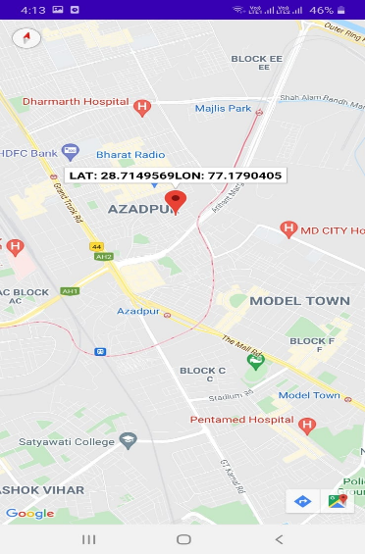 **(7) Showing latitude and longitude on pin-point**

# CHAPTER 7

## CONCLUSION

The aim of this project was to implement advanced location tracking system, obtain the live location and then track the live location for a specified time. The admin can click on each waypoint from the show waypoint list view and can track their location of each. Due to this project, the person can keep the record of previous location and track the current location using GPS.

At the end, we find that, the applications is really useful. The tracker unlike others is free of cost. The network connection module developed would be helpful in N number of scenarios where synchronization or data exchange between devices is desired. The pin point module helps us in locating the current location on the map.

# CHAPTER 8

## FUTURE ENHANCEMENT

After going through the surveying, it can be gathered that there is a huge scope of application development in mobile domain. Following the same notion, we can also develop application that can tackle following issues:

**1) Location positioning technologies**

**2) Query processing**

**3) Cache management**

Applications can be developed on Android platform of Open Handset Alliance led by Google. Google provides simulated environment and standard development kit for developing Android applications. Although this platform is very new and SDK provided is still in its nascent stage, a great number of mobile companies are queuing up to install it on their devices. We chose Android as it is parallel to iOS (supported by Apple) in terms of facilities it provides and is also open source.

Tracker can be modified so as to implement Google Maps V2 APIs. They are more advanced & support 3D projections.

# APPENDIX

# 1. Java

Java is a popular programming language and is an object-oriented scripting language.Java programming language was created by James Gosling, Mike Sheridan, and Patrick Naughton in 1995. The project was initiated in 1991 by them, and a team called sun engineers, later the team/company known as Sun Microsystem. Initially, it was developed for television, but it was not suitable for televisions. It was more advance technology for the television industry at that time. So, it was started to develop for implementation on the digital devices. Currently, Java is being used for developing Internet programming, mobile devices, games, etc.

Java is used to develop mobile apps, web apps, desktop apps, games and much more.

* 1. **2. Android studio**
  2. This IDE was first released in December 2014. At that time version, 1.0 was released. A few days earlier, version 4.2 was released. Android studio has been developed by Google and JetBrains. It can be operated in multiple Operating systems, like Windows, macOS, Linux, Chrome OS. Java, Kotlin, C++ are the programming language which commonly used to develop applications with this IDE. The installation package and brief installation instructions can be found on the Google authorized Android studio developer site. Currently, version 4.2 of Android Studio is available for developers. Android Studio is embedded with multiple features such as Layout editor, Templets, Support Kotlin, Integrated Firebase, Emulator, etc.
  4. **3. Things we'll implement in building this tracker are:**
     + API’s
     + Google Play Services

# 

# REFERENCES

[1]. Virrantaus, K., Markkula, J., Garmash, A., Terziyan, V., Veijalainen, J., Katanosov, A., and Tirri, H. Developing gissupported location-based services. In Web Information Systems Engineering (2001), IEEE, pp. 66_75.

[2]. Consortium, O. G. Open location services 1.1, 200

[3] Yi-Chen Shih; Yu-Ming Liang; Sei-Wang Chen, "Demo paper: Smartphone-based automatic stolen vehicle detection system," Multimedia and Expo Workshops (ICMEW), 2013 IEEE International Conference on, vol., no., pp.1,2, 15-19 July 2013

[4] Wright, M., Stallings, D., Dunn, D.: The Effectiveness of Global Positioning System Electronic Navigation. April 2003, IEEE Southeastcon 2003. Bridging the Digital Divide. Renaissance Jamaica Granade Resort Ocho Rios, St. Ann, Jamaica WI

[5] FreeCodeCamp Android Tutorial

[6] Web Resource: http://www.stackoverflow.com

[7] Web Resource: <http://developer.android.com/index.html>

[8] Web Resource: https://developers.google.com/map